1) Created a document object   
 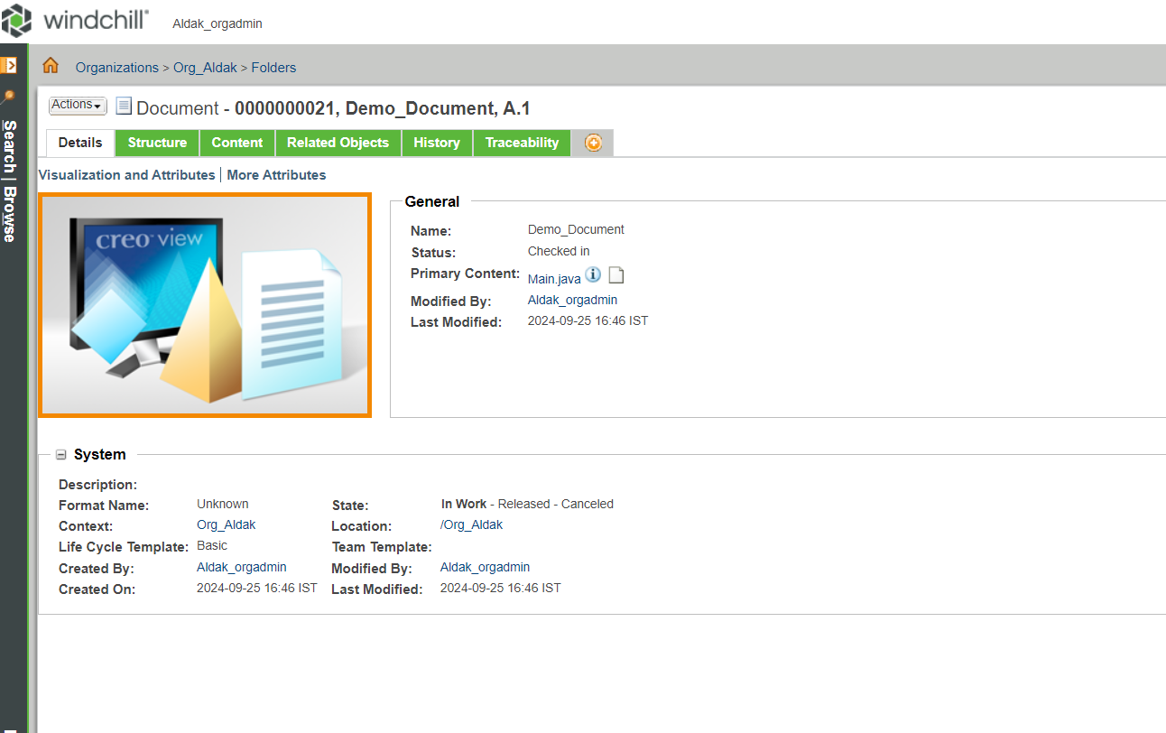  
  
  
2) Inserted a Primary and Secondary content respectively in below slides  
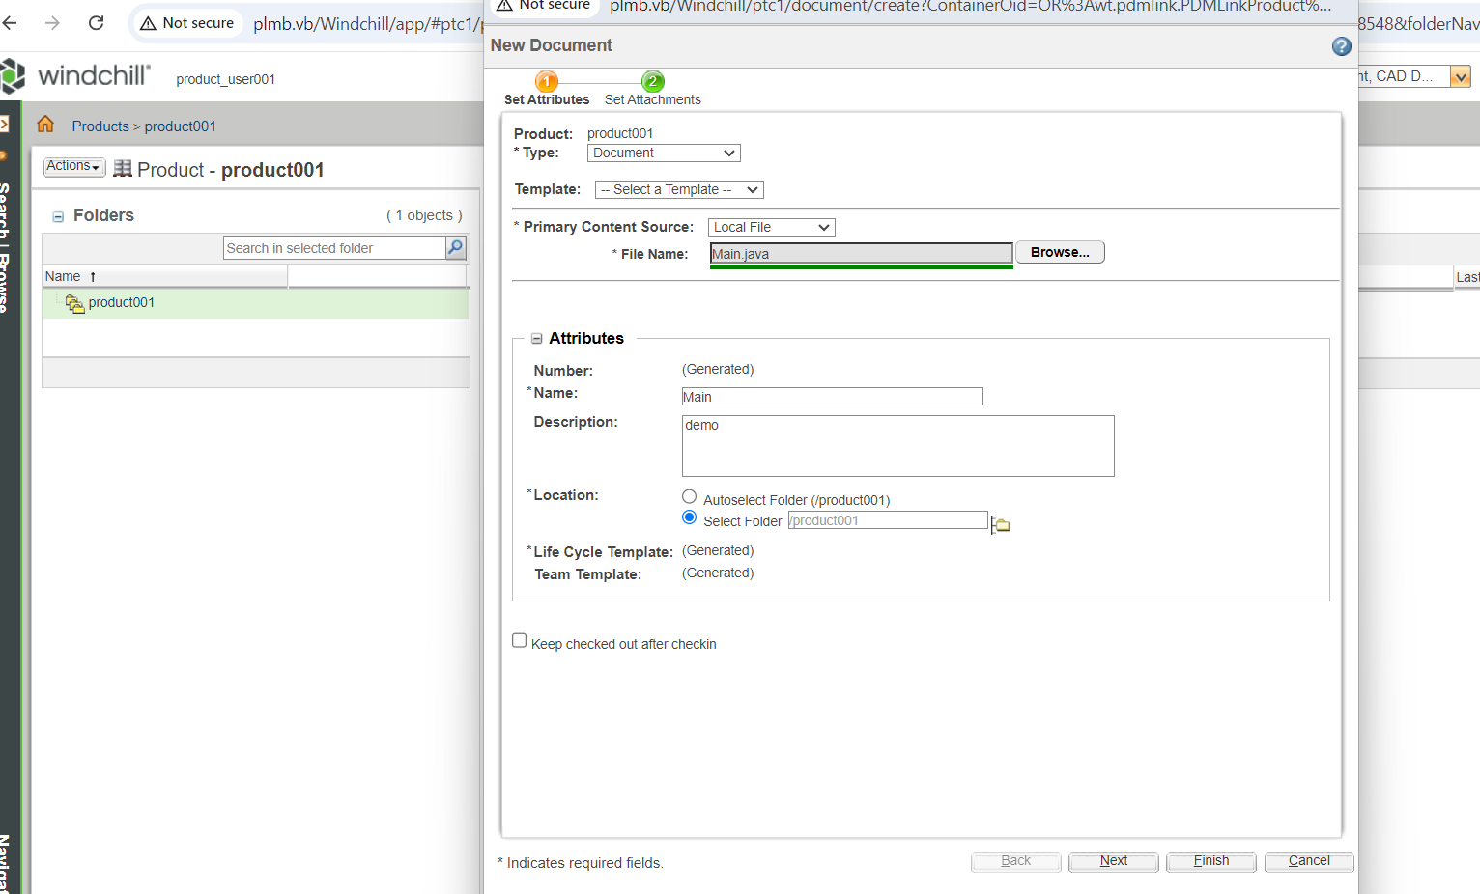

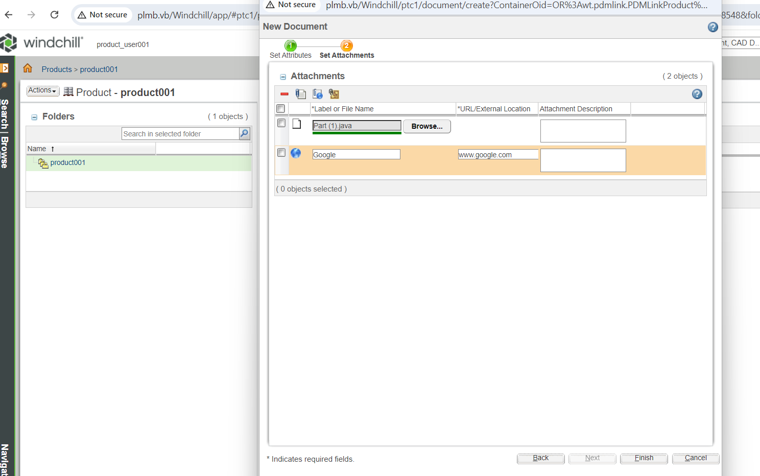

3) doc to doc linkage(parent child relationship), then checked in for saving it  
  
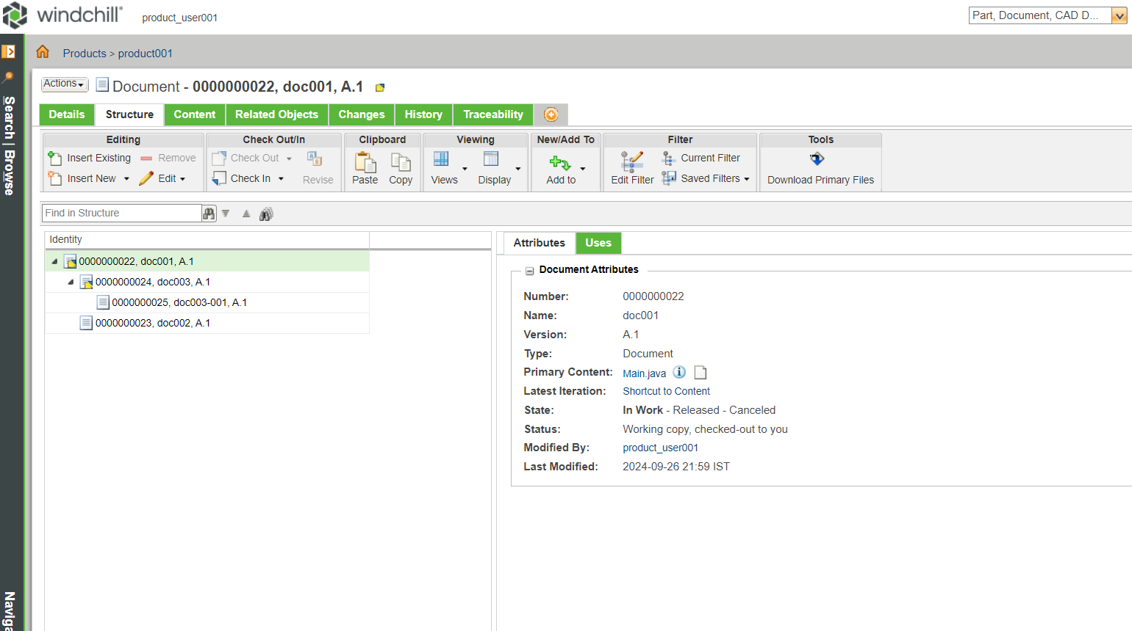  
  
  
  
  
  
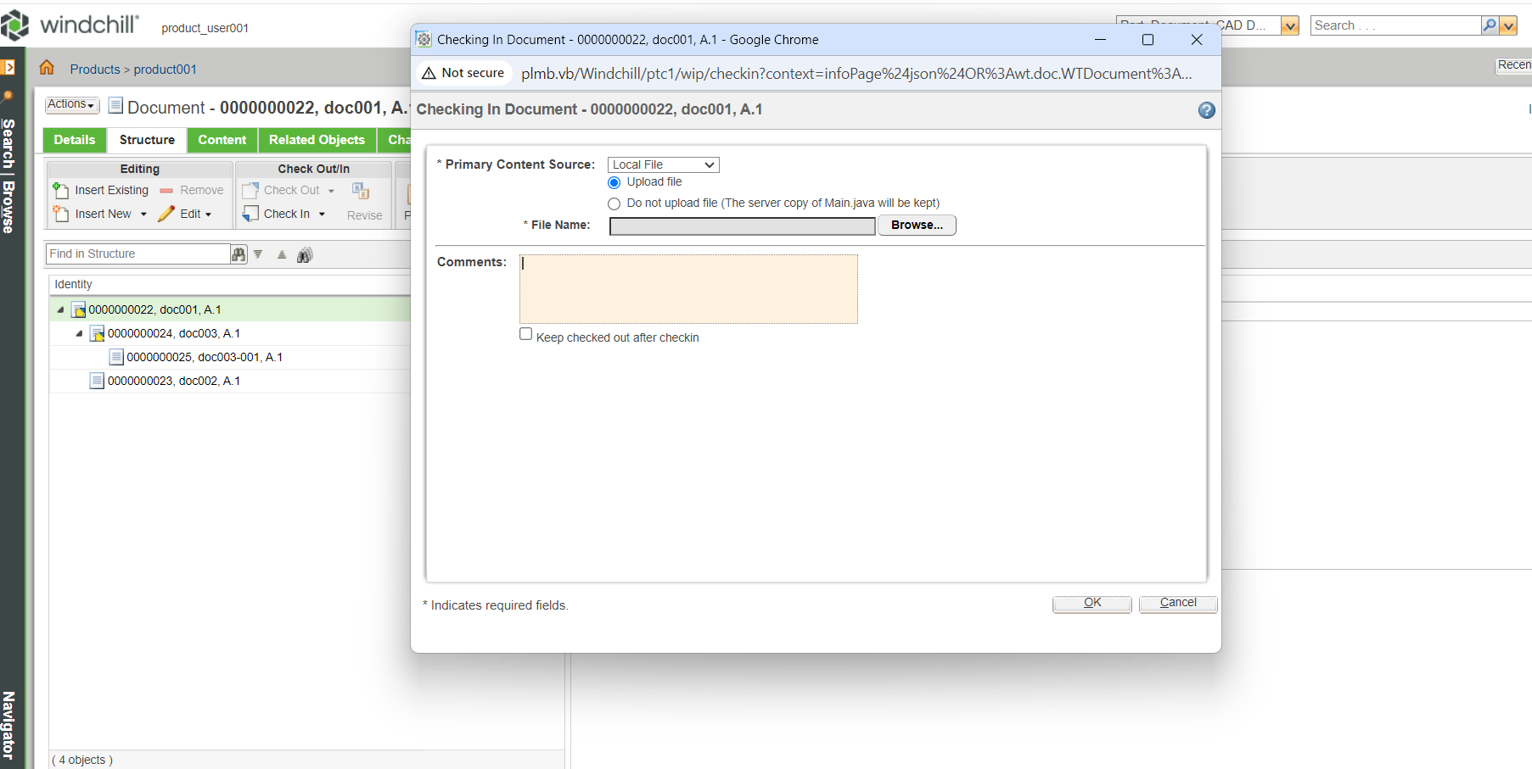

4) Part to doc linkage where part is parent and doc are child.  
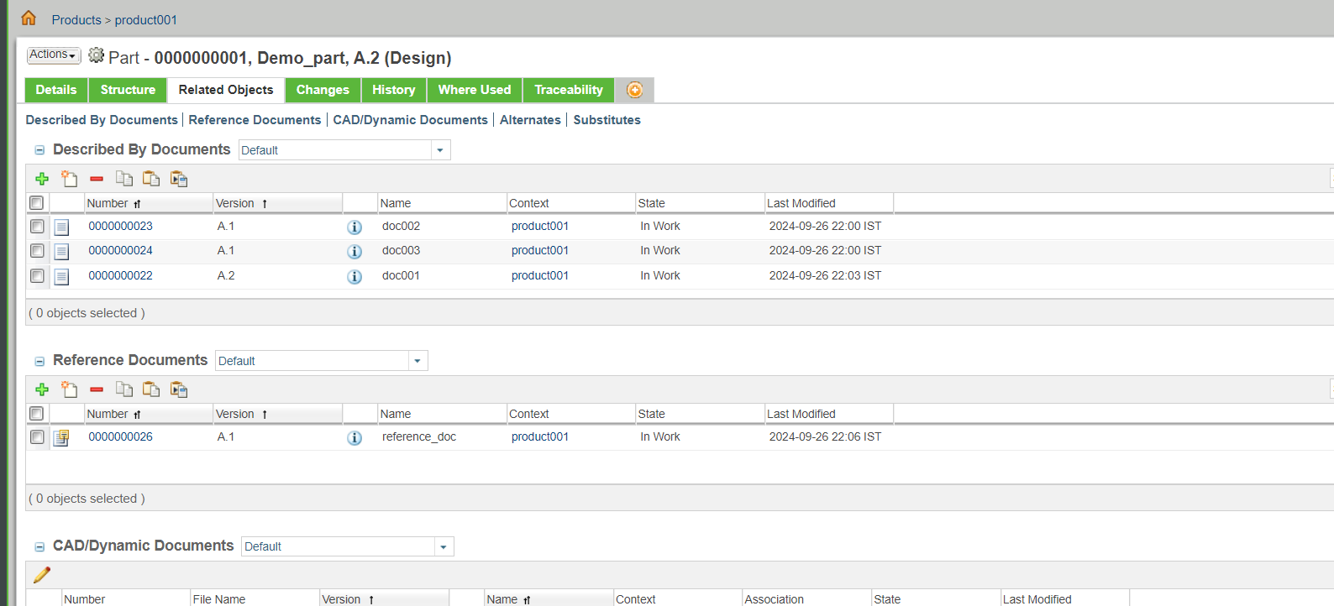  
  
  
  
  
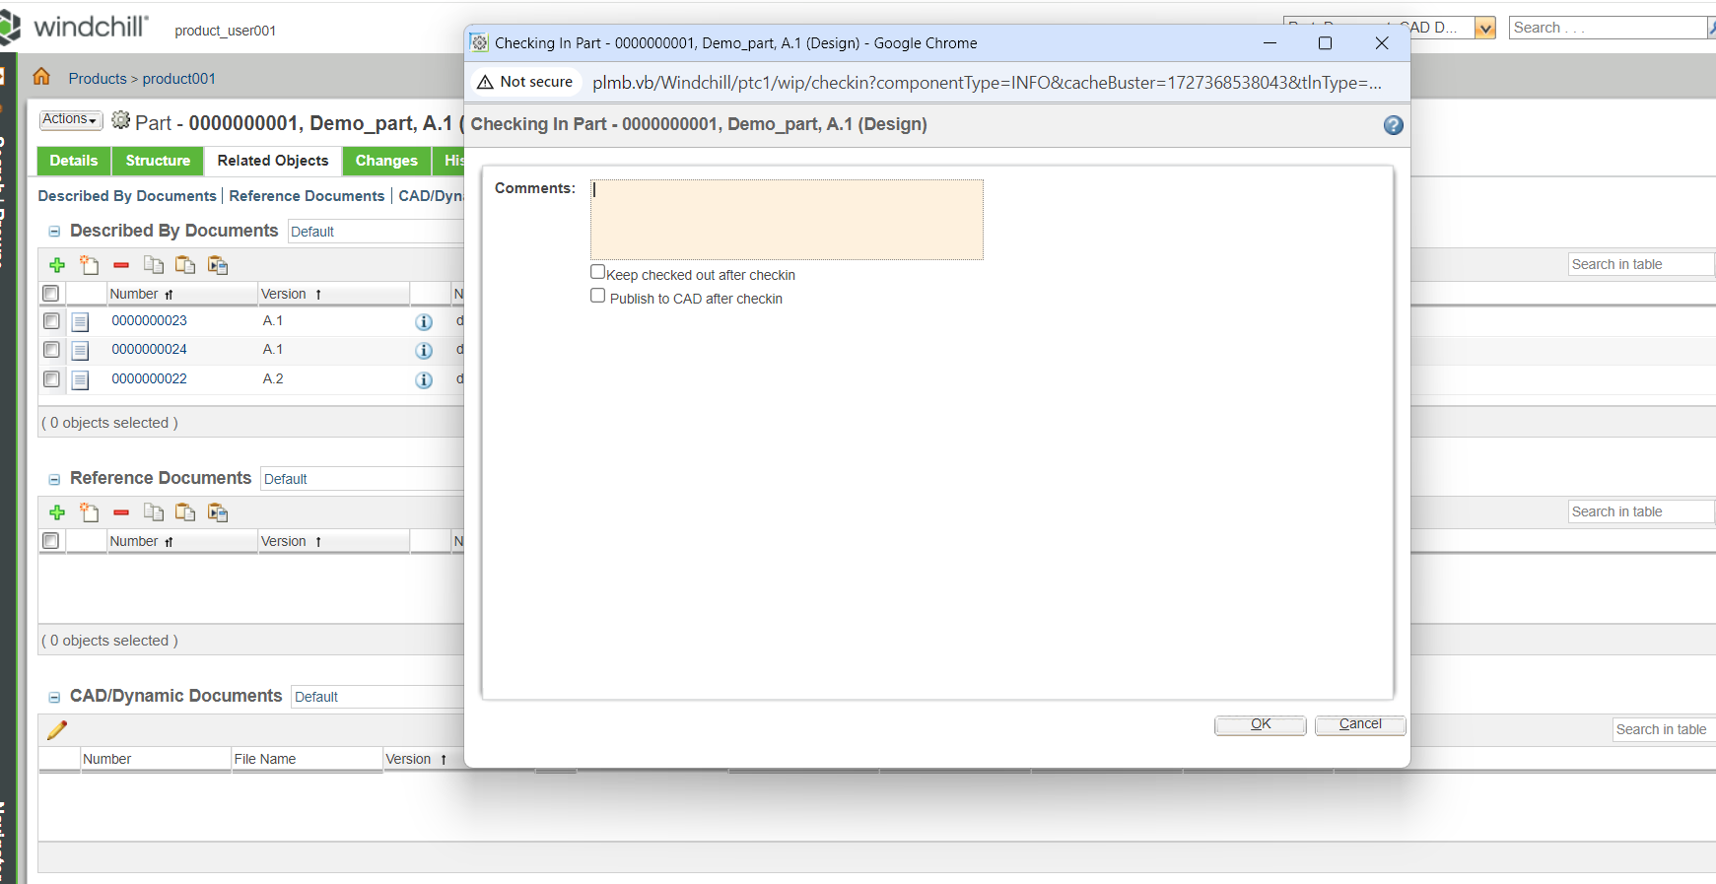

5) Created a BOM through part to part linkage,  
  
